# 62 – Testing of Module 07 in Echelon

## Module 7.1 running on 24V motor

1. First, calibrate the 24V motor by using the Tachometer and check the max speed that the motor can reach from the Pulse roller.
   1. From the FB in the Program Blocks -> 04 Horizontal Diverter -> HD_MotorManagement_V1 -> Network 4, insert the inputs I_MaxVelocityofMotor and I_Rotation_range_MaxVe_2.
   2. For reference you can check the Orebro project, and the speed calibration excel file.
2. The current module 7.11 and 7.12 forward motion is connected to the 24V motor, so we need to check how much speed fluctuates on low and high speed.
   1. To do this process set different speed set points and check on the trace graph how much it is changing. For example, first put 500 mm/s seconds and then if it is changing then check why it is fluctuating maybe we can check the values of current and voltage on Pulse Roller software if they are stable for not. Same do the process at low speeds and try to find the stable speed where there is less fluctuation.
   2. Make a graph of the real speed and setpoint speed using trace.
3. Try to find the stable values for the ramp up and ramp down (acceleration and deceleration).
   1. Check how much time it takes to reach the setpoint speed when we change these ramp values.
   2. We can map this on the tracer
   3. If we try to increase the ramp values then at a certain point we will notice the jerks, so we must trace those values also.
4. Similarly to this test with the rotation of the motor
5. Finally compare your findings with the 400V motor.

### Calibrations

1. Both motors of the MD7 (24V and the 400V) were calibrated to run at the same speed of 1000 mm/s – Measured from Tachometer = 60 m/min
2. Legends : (Blue – 24V, Green – 400V)

#### Test 1:

24V Motor: Speed = 1000 mm/s, Accel = 100 pulses, Decel = 100 pulses

400V Motor: Speed = 1000 mm/s Accel Factor = 0.35

*Observation: Changing in the accel/decel pulses does not affect the on the acceleration/deceleration time of the 24V motor*

1. Acceleration:

1. Steady State:

1. Deceleration:

#### Test 2:

24V Motor: Speed = 500 mm/s, Accel = 30 pulses, Decel = 30 pulses

400V Motor: Speed = 500 mm/s Accel Factor = 0.35

1. Acceleration

1. Steady State

1. Deceleration

#### Test 3:

24V Motor: Speed = 1500 mm/s, Accel = 100 pulses, Decel = 100 pulses

400V Motor: Speed = 1500 mm/s Accel Factor = 0.35

*Observation: Higher Speeds -> Low fluctuations*

1. Acceleration

1. Steady State

1. Deceleration

#### Test 4:

24V Motor: Speed = 1000 mm/s, Accel = 100 pulses, Decel = 100 pulses

400V Motor: Speed = 1000 mm/s Accel Factor = 0.8

*Observation: By increasing the acceleration factor then the acceleration/deceleration time shortens*

1. Acceleration

1. Steady State

1. Deceleration

# New Testing's on 24V motor in MD7.1 in 62

# (23/24 April 2025)

1. Try with big parcel to check on different speed (the sample rate is 0.5secs)
2. Put reference speed on trace

#### Test 1:

24V Motor: Speed = 1000 mm/s, Accel = 100 pulses, Decel = 100 pulses

Condition: No Rotation and No Parcel

Acceleration:

Steady State

Deceleration:

#### Test 2:

24V Motor: Speed = 1000 mm/s, Accel = 100 pulses, Decel = 100 pulses

Condition: No Rotation and With Parcel (120cm X 40cm and weght 8-10kg)

Steady Condition:

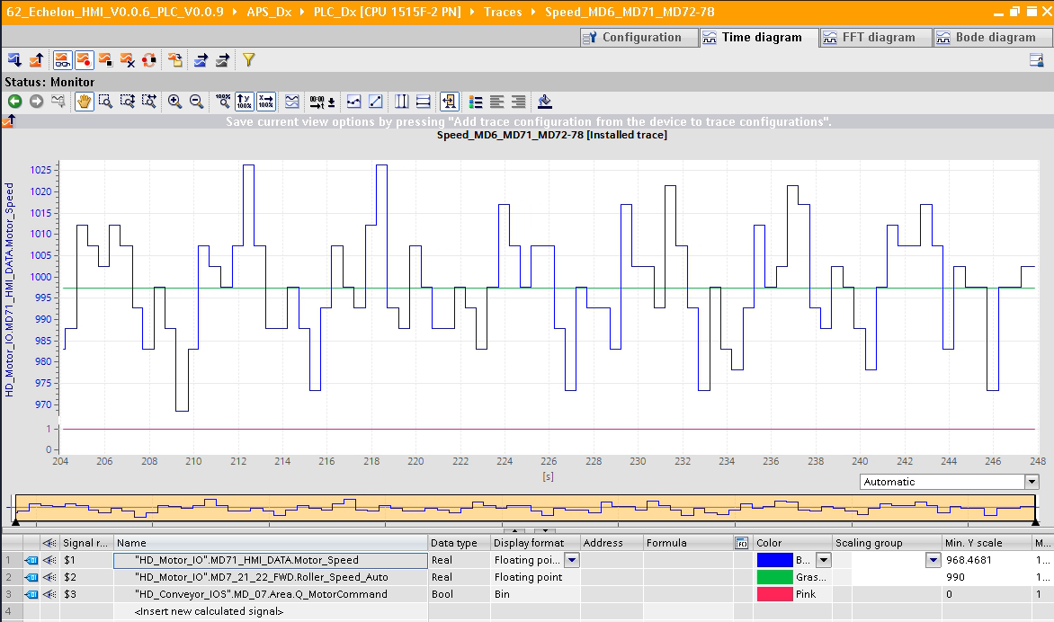

During the motion of the parcel over the MD07. No dramatic speed drops were noticed. The speed fluctuated under the range 970 – 1030 as of normal speed fluctuation

#### Test 3:

24V Motor: Speed = 1000 mm/s, Accel = 100 pulses, Decel = 100 pulses

Condition: With Rotation and With Parcel (120cm X 40cm and weght 8-10kg)

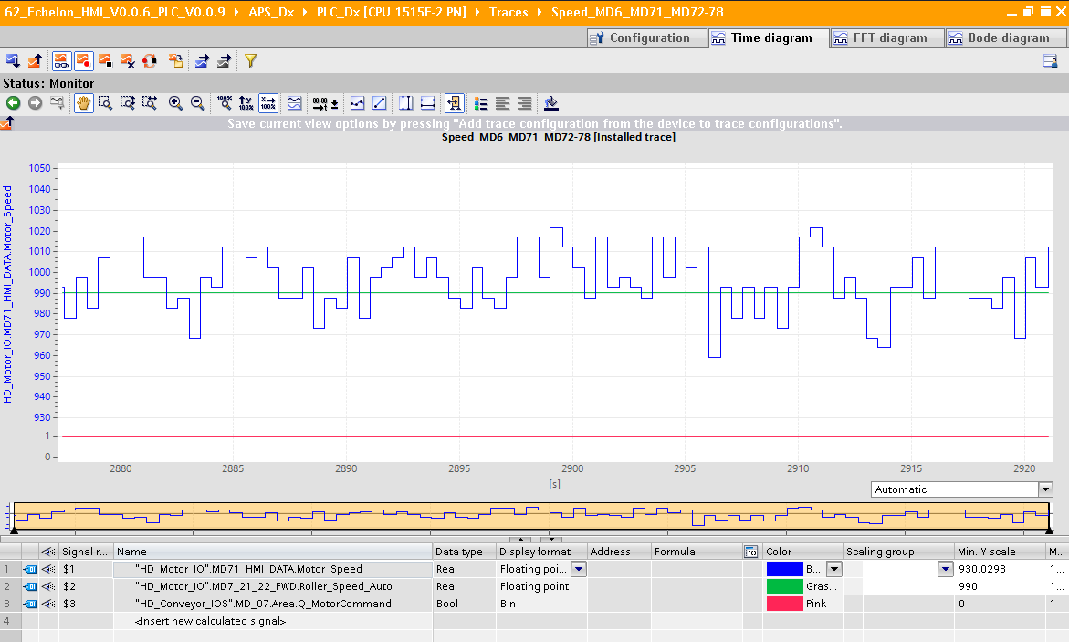

#### Test 4:

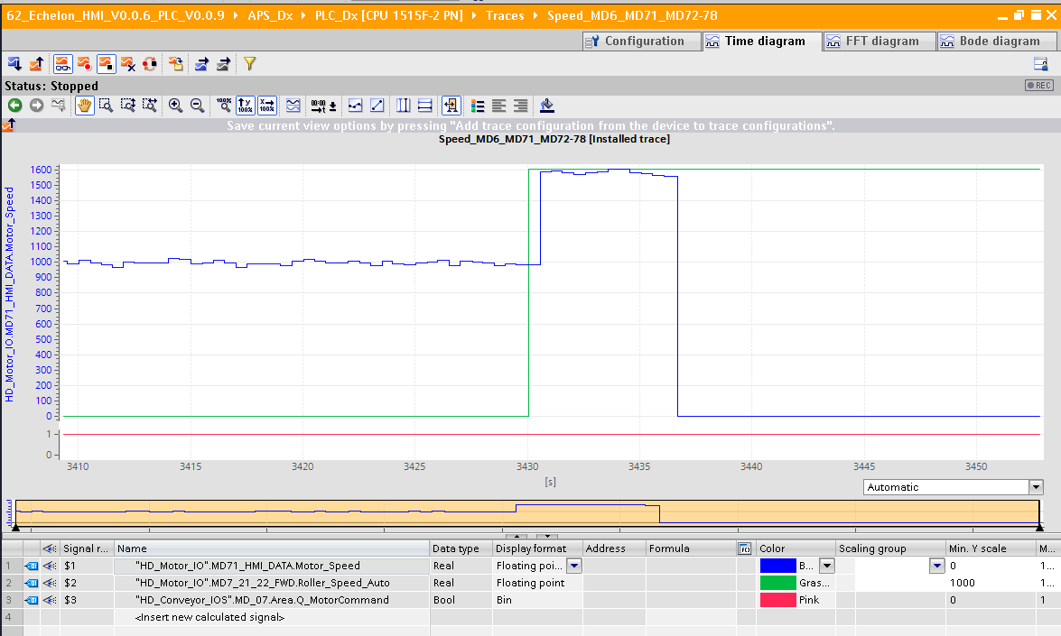

Change of speed from 1000 to 1600. 24V went to error after some time

#### Test 5:

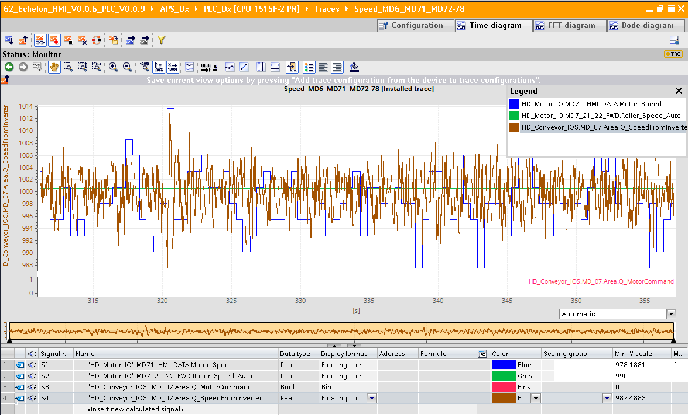

1000 speed for both 24V and 400V without parcels and no diverted condition

#### Test 6:

Ranges calibrated Y -axis

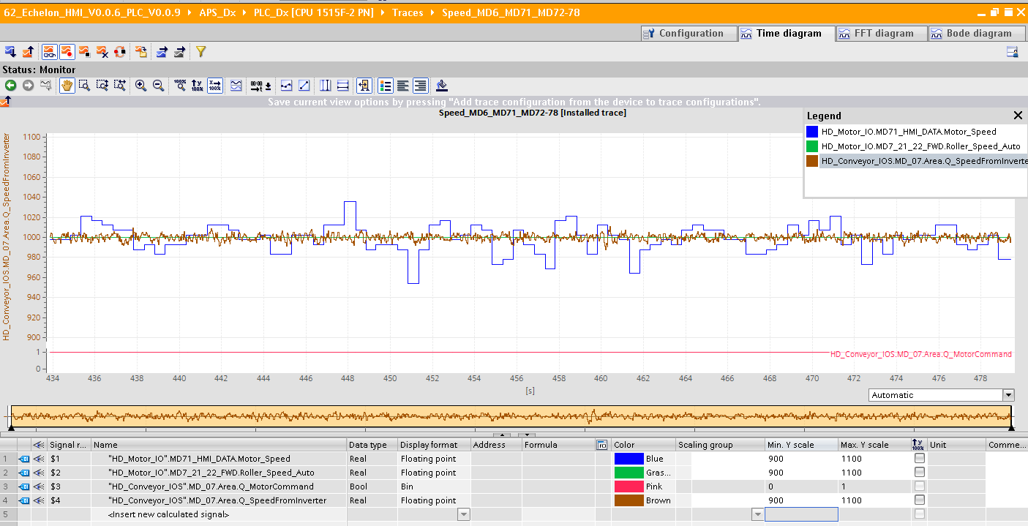

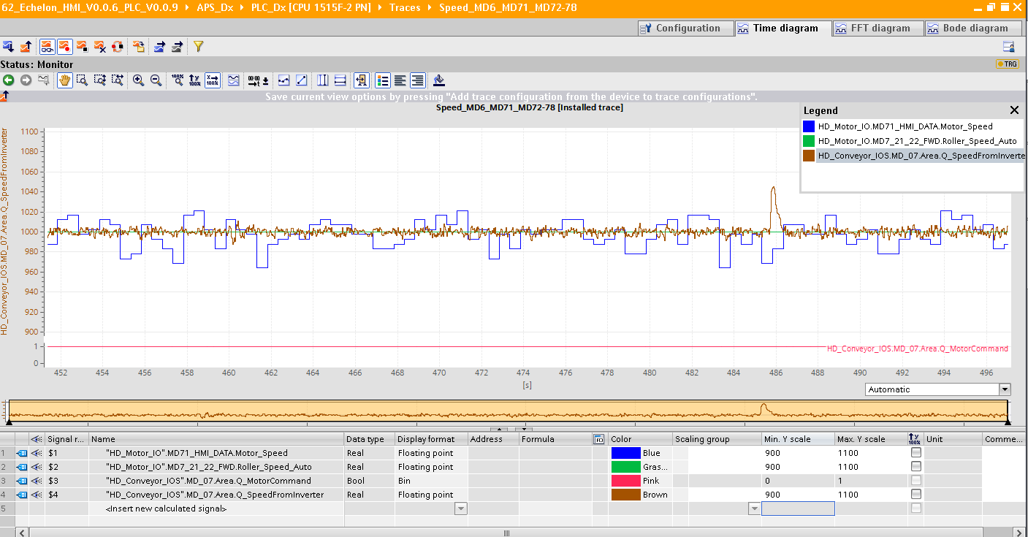

#### Test 7:

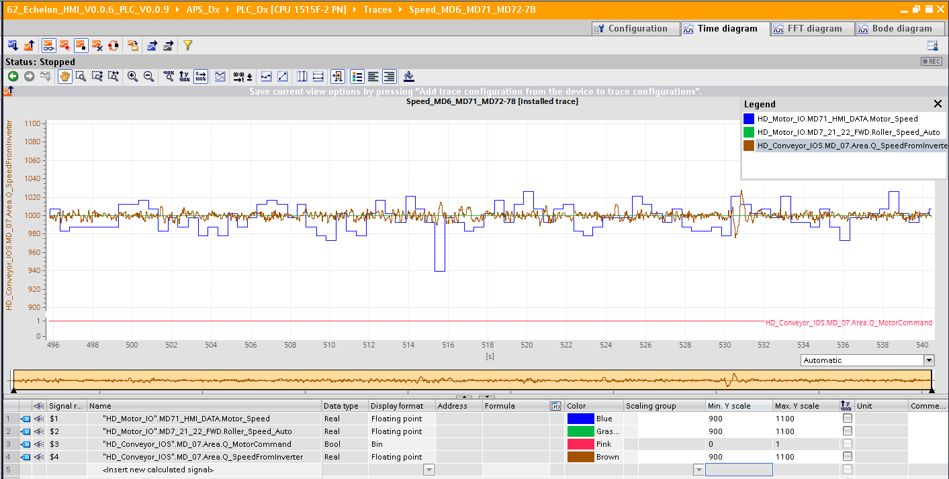

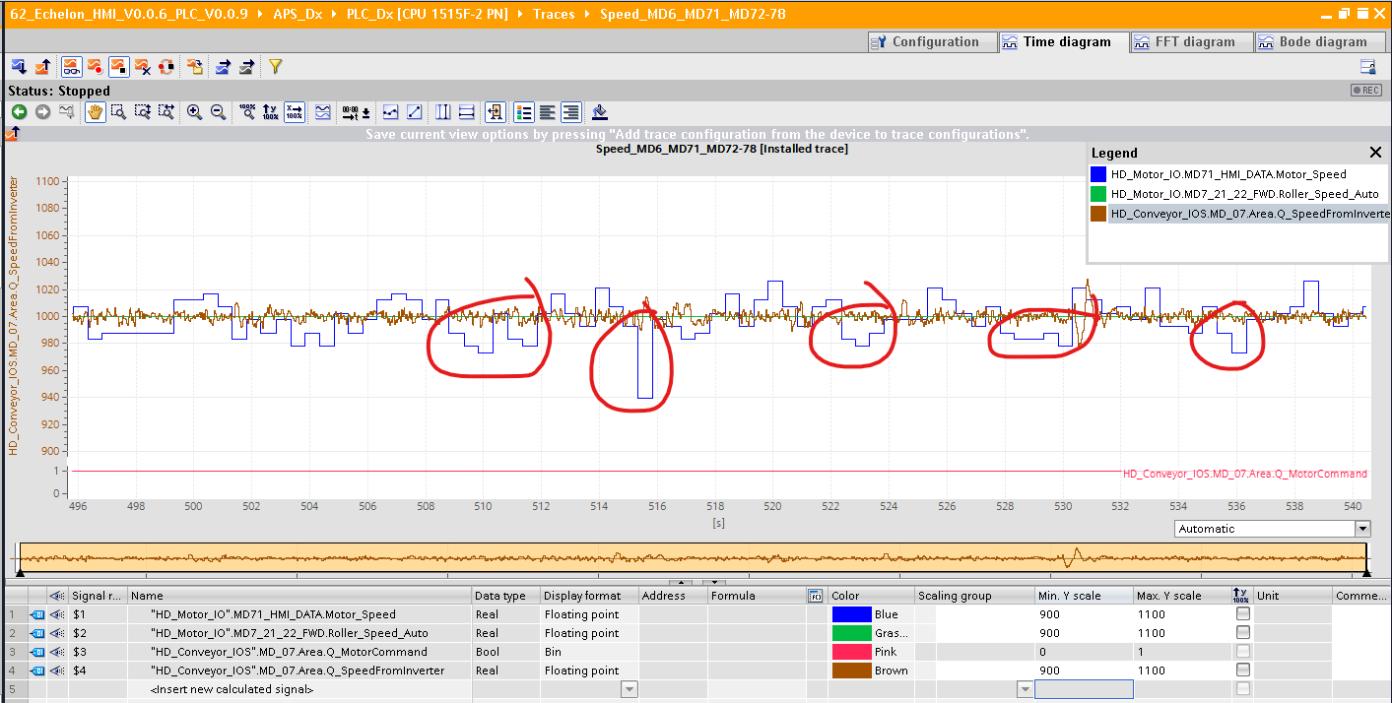Parcels without diverted condition

#### Test 8:

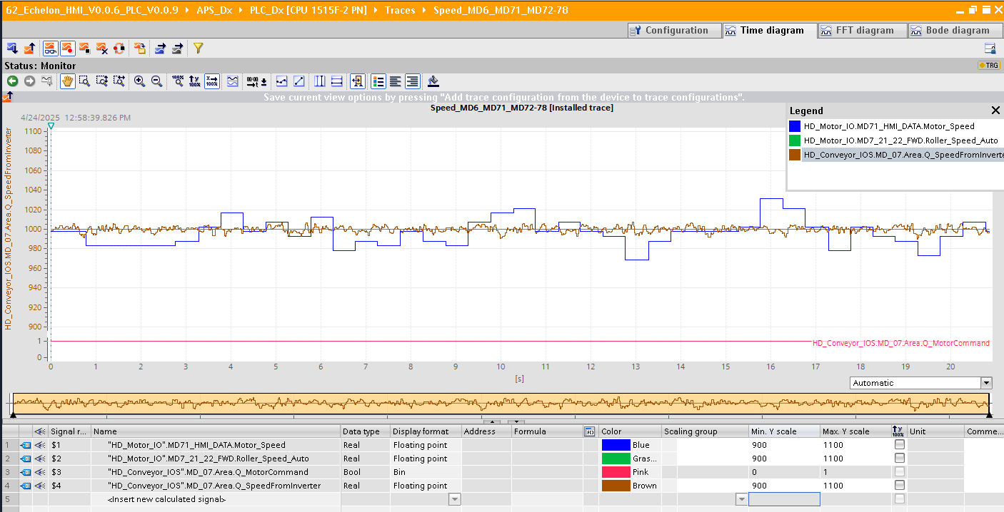

Speed of MD07 when it is in diverted condition

#### Test 9:

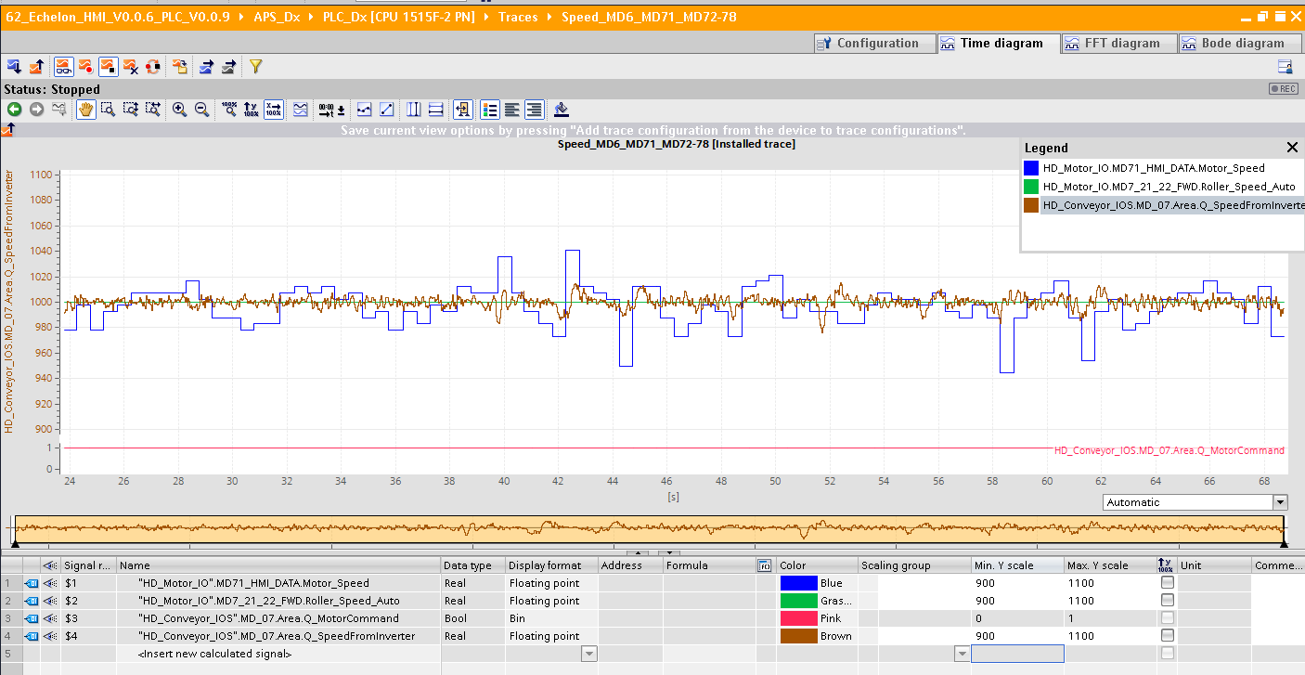

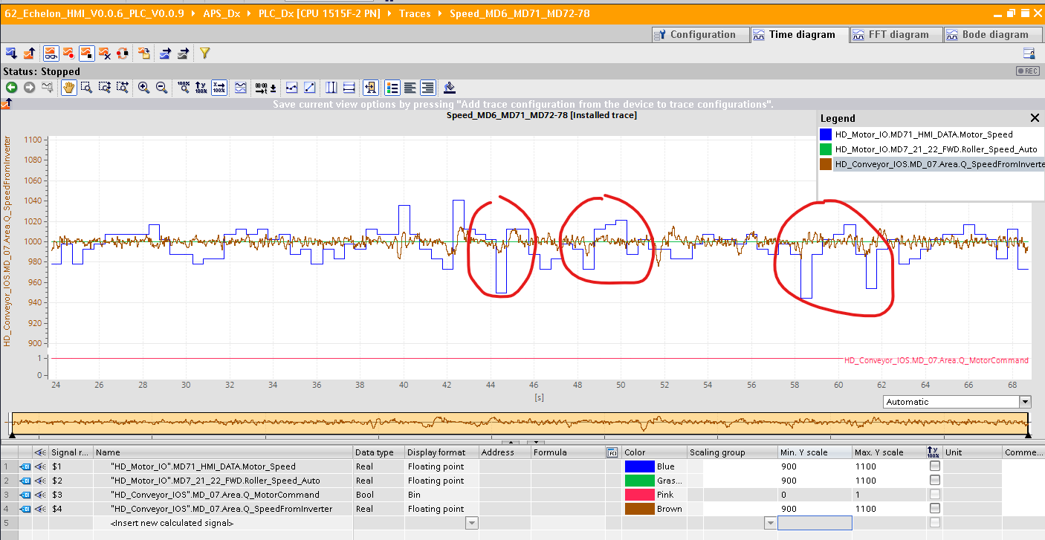

Diverted with parcels

#### Test 10:

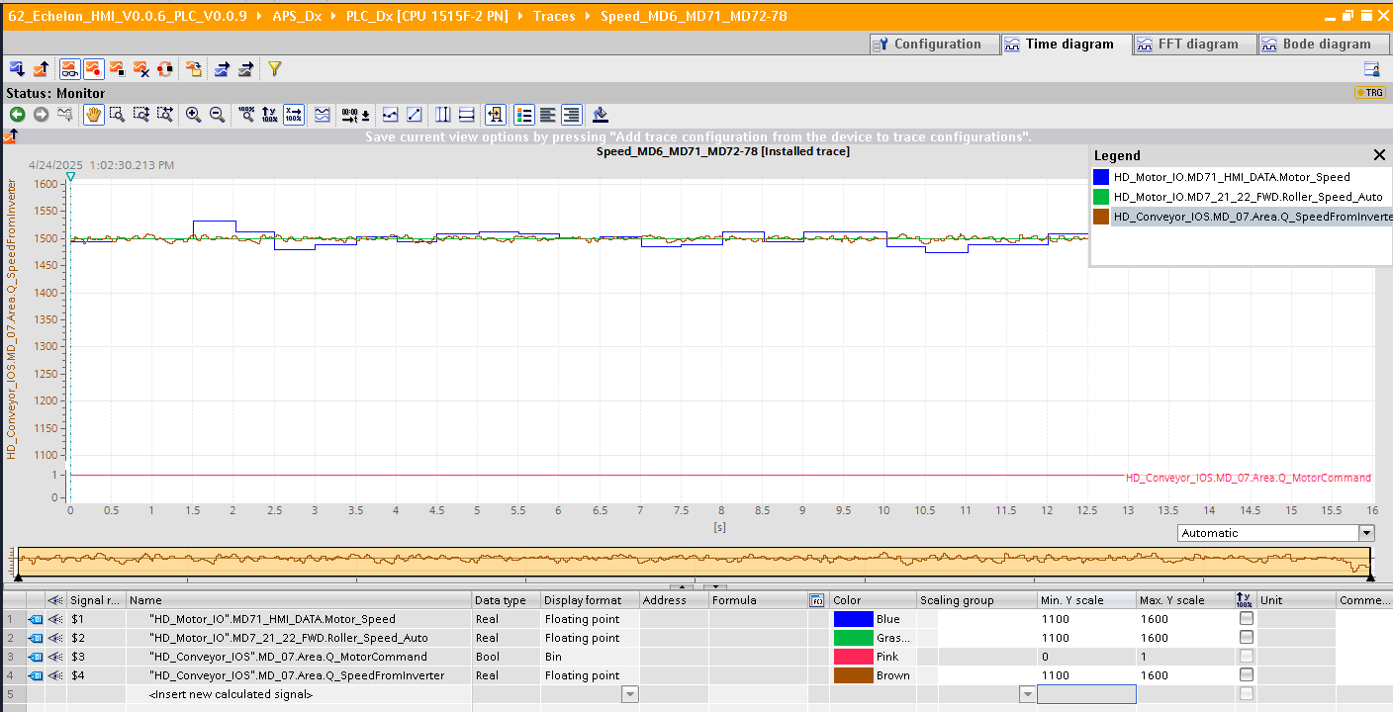

1500 speed with diverted state

#### Test 11:

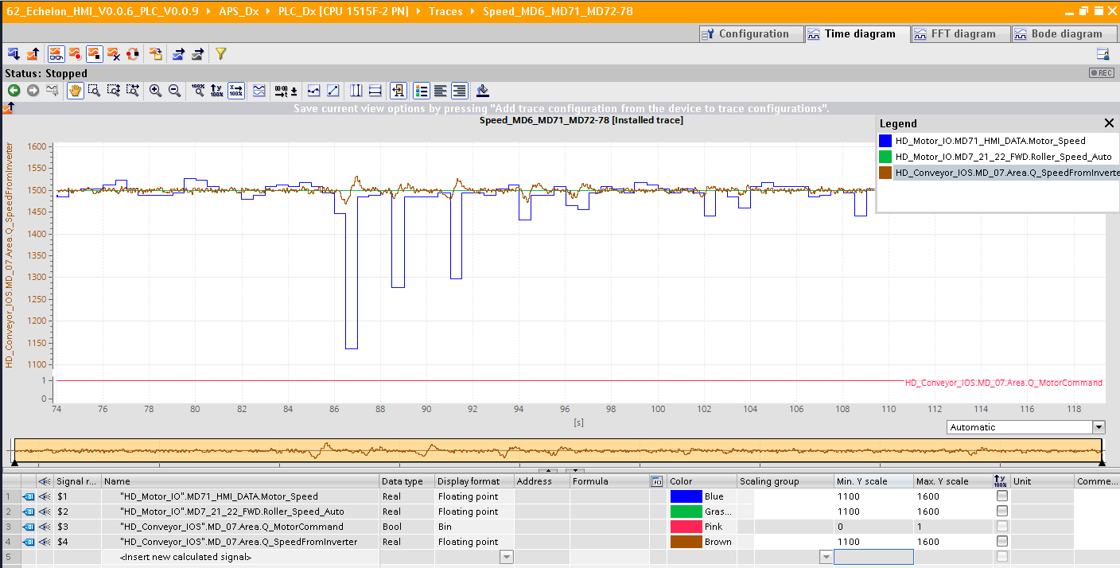

1500 speed with diverted state and parcels

#### Test 12:

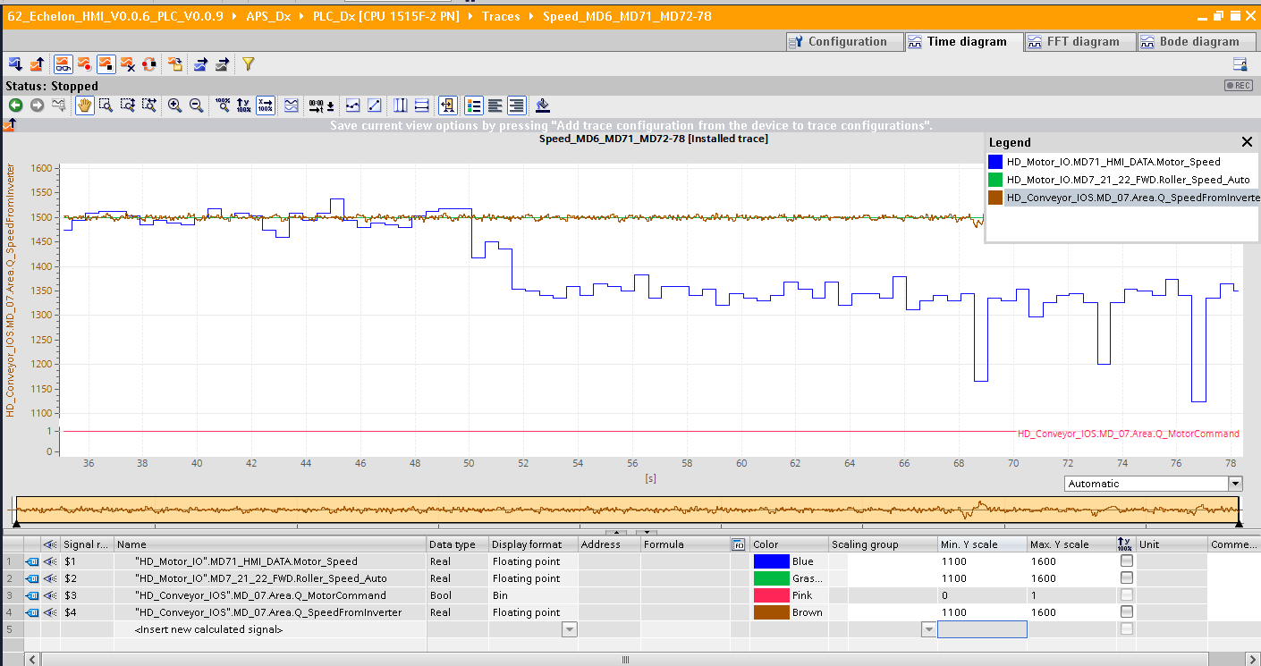

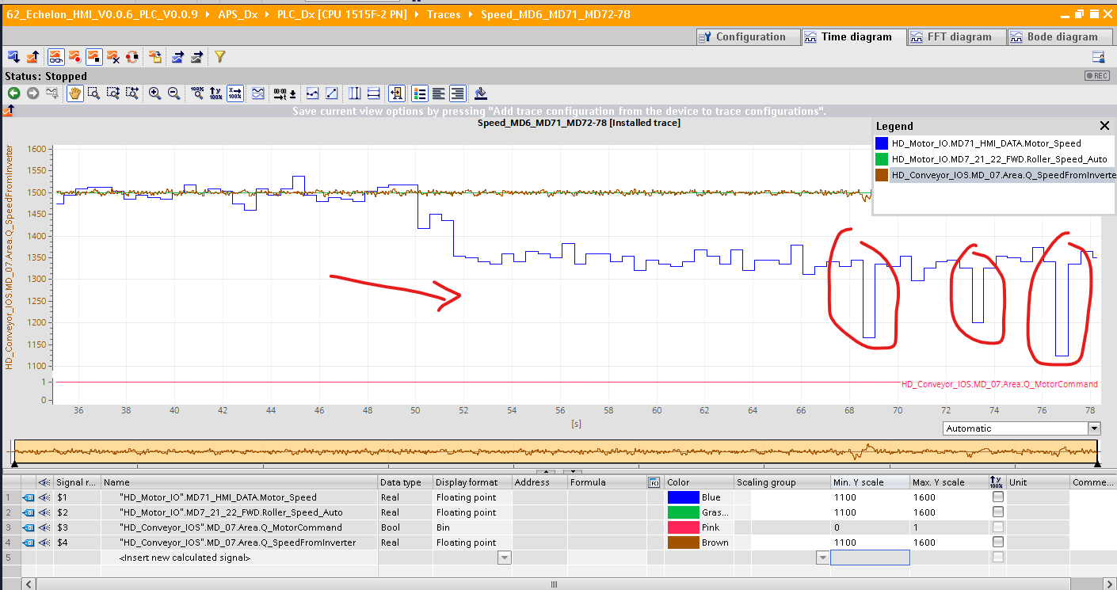

Change type from boost 8A to ECO and then diverted condition with parcels

#### Test 12:

Turns with parcels only 24V motor

